Dairy Goods Sales Analysis

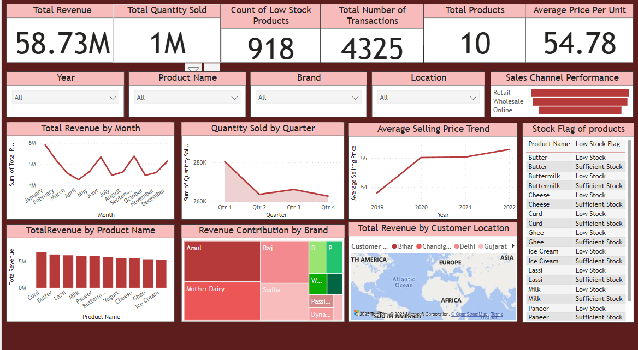

Sales and Inventory Dashboard Overview

This dashboard provides a comprehensive overview of the company's sales and inventory performance. Key highlights include a total revenue of 58.73M from 1M units sold, across 4,325 transactions and 10 product categories. It tracks important metrics such as low stock product count (918), average price per unit (54.78), and sales channel performance (Retail, Wholesale, Online).  
  
Visualizations display total revenue by month, quantity sold by quarter, average selling price trends, and revenue contribution by product and brand. The dashboard also features a map showing total revenue by customer location and a detailed stock status report by product.